



### E-Project Documentation

**Teacher Name: Ma’am SYEDA IMAMA ALI APTECH COMPUTER EDUCATION HYDERABAD-1 PAKISTAN**

**Issue Date: 26-January-2024**



TABLE OF CONTENT

|  |  |  |
| --- | --- | --- |
| **S No** | **Contents** | **Page No** |
| 01 | Certificate | 3 |
| 02 | Acknowledgement | 4 |
| 03 | Project Report | 5 |
| 04 | Problem Definition | 6 |
| 05 | Customer Requirements  Specification (CRS) | 7 |
|  |  |  |
| 06 | System Requirement | 8 |
| 07 | Task Sheet | 10 |
| 08 | Project Plan | 11 |
| 09 | Checklist of work Progress | 12 |
| 10 | Screen Shots | 13 |
| 11 | Source Code | 24 |



# CERTIFICATE

This is to certify that

**AHSAN BAIG**

Has successfully Designed

THE MERCADO AMUSEMENT PARK

Submitted by:

### SAWERA MAHAR

Date of Issue: 4-JANUARY-2024

Authorized Signature**:Ma’am SYEDA IMAMA ALI**



# ACKNOWLEDGEMENT

First and foremost, we would like to express our deep gratitude and most heartfelt thanks to almighty ALLAH for his blessings, for lightening up our heart with the torch of knowledge and for giving us the ability to complete this project.

We would like to thanks Aptech Worldwide and the team of E- Project for their generous support and clarifying the doubts regarding e-project. We would like to acknowledge the way of explanation which the team of e-project gave in e-project to make website and we are equally grateful to our teacher (Ma’am SYEDA IMAMA ALI) for giving us a moral support and guiding us different matters regarding project in all the time about the research and writing of this project.

We are greatly indebted to Aptech Worldwide, Ma’am SYEDA IMAMA ALI, Faculty Members and ACE Hyderabad, Pakistan for encouragement and incessant help.



# PROJECT REPORT

**BY:**

**SAWERA MAHAR, AHSAN BAIG, ABDUL SHAKOOR**

**AND HAMMAD SIDDIQUI**

**Project Title: THE MERCADO AMUSEMENT PARK,**

**Members Name: SAWERA MAHAR**

**AHSAN BAIG**

**HAMMAD SIDDIQUI and**

**ABDUL SHAKOOR**

**Batch Code: 2307F**

**Start Date: 4- JANUARY-2024**

**End Date: 26-JANUARY-2024**

**Course: ACCP (CPISM)**

**Teacher: Ma’am SYEDA IMAMA ALI**

**Center Manager: Sir SHOAIB AHMED Center Academic Head: Sir ZUBAIR**

Submitted as

E Project Documentation



**PROBLEM DEFINITION**

Merciado Amusement park is now prime focus of the city and nation. It is made by

Seth groups of companies. The development of this park took 5 years to get their

desired finished product. It has became nation pride now. The area of theme park is

about 45 acre land. The Management has put all the efforts to keep the attractions

operational. The merciado management wants you to develop the website of the

park which should include describing all the attraction of the park and also allow the

user to book the ticket online.

Requirement Specification:

The Web site is to be created based on the following requirements.

1) The home page must be designed with beautiful color combination with all the

required links defined properly. Also all the section of the webpage must be in

used to avoid the blank space.

2) Different Zones and attraction, Restaurants, Entertainment, Tickets and

Prices, Gallery be described in different webpage.

3) Prices value must be show the differences as per the day (like weekend or

weekday or family pack).

4) About us, Contact Us, Disclaimer must be included.

5) Creating an account facility can also be added.

6) Dummy procedure for booking the ticket can be added.

7) Sitemap must be added.

8) Navigation of the project must be made smooth.



PROJECT OBJECTIVE:

* The Objective of this program is to give a sample project to work on real life projects. These applications help you build a larger more robust application.
* The objective is not to teach you HTML/JavaScript/Dreamweaver/HTML5 but to provide you with a real life scenario and help you create basic applications using the tools.
* You can revise the chapters before you start with the project.
* This project is meant for students who have completed the module of ***Dreamweaver***. These programs should be done in the Lab sessions with assistance of the faculty if required.
* It is very essential that a student has a clear understanding of the subject. Students should go through the project and solve the assignments as per requirements given.
* Kindly get back to EProjects Team in case of any doubts regarding the application or its objectives.



**Hardware/ Software Requirements**

**Hardware**

* A minimum computer system that will help you access all the tools in the courses is a Pentium 166 or better
* 64 Megabytes of RAM or better

**Software *[Either or Combination as per Course/Sem]***

* **Notepad/HTML editor/CoffeeCup**
* **Angular / Angular JS / React / BootStrap**
* **Dreamweaver / Figma**
* **MS IE / Chrome / FireFox / Netscape /MS Edge**



**System Requirement:**

|  |  |  |
| --- | --- | --- |
| **SR.No** | **Items** | **Description** |
| 01 | Operating System | Window XP, Win7 or win8 |
| 02 | Main Processor | Minimum 2ghz or better |
| 03 | Ram (Memory) | Minimum 512mb or better |
| 04 | Web Browser | Google Chrome or Firefox (Latest) |
| 05 | Software | Notepad, HTML editor, Adobe Dreamweaver CS5.5 |



TASK SHEET



|  |  |  |  |  |  |
| --- | --- | --- | --- | --- | --- |
| **Project Ref. No:** | | **Date of Preparation of Activity Plan:** | | | |
| SR.  No | Task | Actual Start Date: | Actual Day: | Team Mates Names: | Status: |
| 01 | Planning | 6-Jan-2024 | 1 | SAWERA  And  AHSAN | YES |
| 02 | Data Collection | 8-Jan-2024 | 1 | SAWERA  And  AHSAN | YES |
| 03 | Designing Home Page | 9- Jan-2024 | 4 | SAWERA  And  AHSAN | YES |
| 04 | Linking | 10- Jan-2024 | 9 | SAWERA  And  AHSAN | YES |
| 05 | Check Links | 13- Jan-2024 | 2 | SAWERA  And  AHSAN | YES |
| 06 | Finalizing | 15- Jan-2024 | 3 | SAWERA  And  AHSAN | YES |
| 07 | Testing | 17- Jan-2024 | 2 | SAWERA  And  AHSAN | YES |
| 08 | Documentati on | 20- Jan-2024 | 1 | AHSAN | YES |



|  |  |  |  |  |  |
| --- | --- | --- | --- | --- | --- |
| 09 | Uploading | 26- Jan-2024 | 2 | Sawera,Ahsan | YES |

PROJECT PLAN

* Website is able to execute quickly.
* The color scheme of the site looks attractive.
* The collection of data is authentic and taken by the most popular product websites.
* There is authentic information of facilities products with their specifications.
* Background is different to main page.
* The HOME is well prepared exactly for the same page as user clicks on the link..
* A visitor can also view the individual image of our every gallery.



**CHECK LIST OF WORK PROGRESS**

|  |  |  |
| --- | --- | --- |
| **SR:No** | **Aspect Tested** | **Remarks** |
| 01 | Data Collection | **yes** |
| 02 | Designing Home Page | **yes** |
| 05 | Linking The Pages | **yes** |
| 06 | Finalization | **Yes** |
| 08 | Tasting The Site | **Yes** |



|  |  |  |
| --- | --- | --- |
| 09 | Documentation | **yes** |

**Screen shot of the Websites**

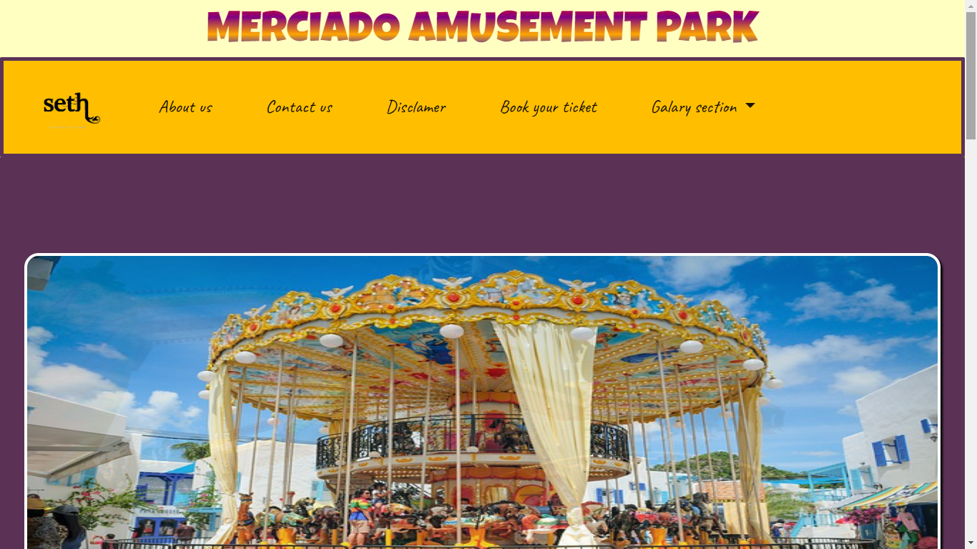Home-page-1

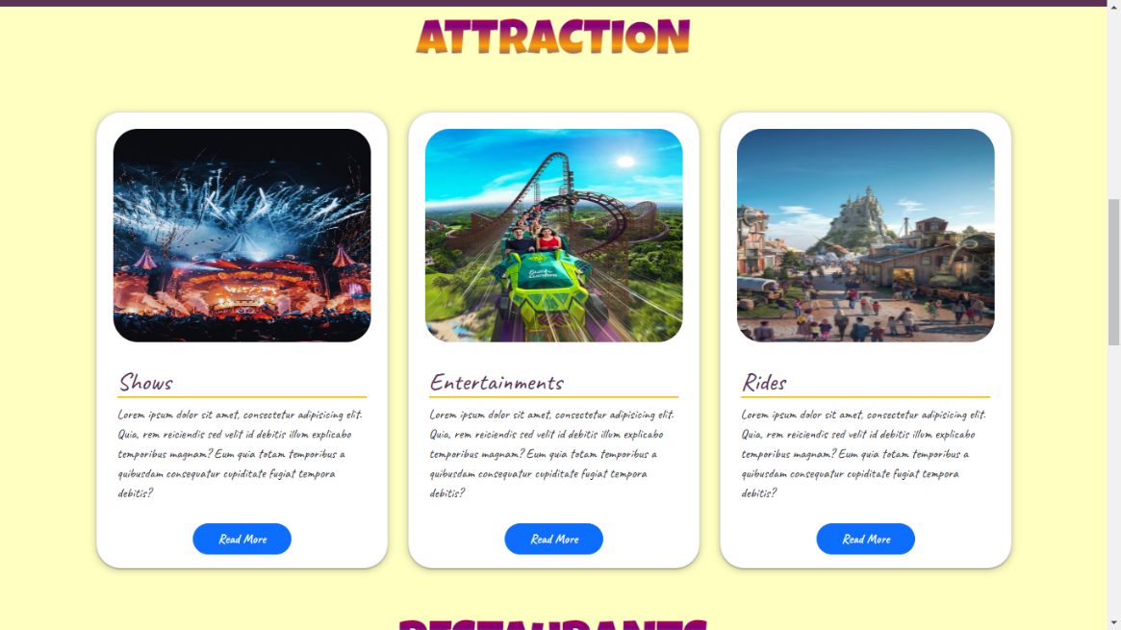



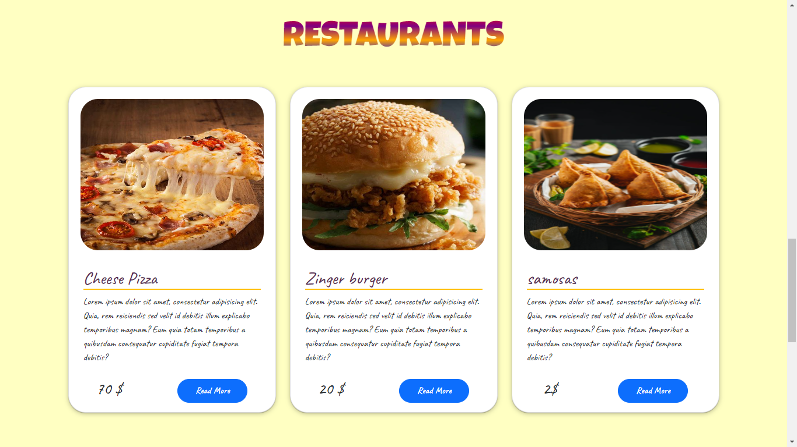Home-page-2

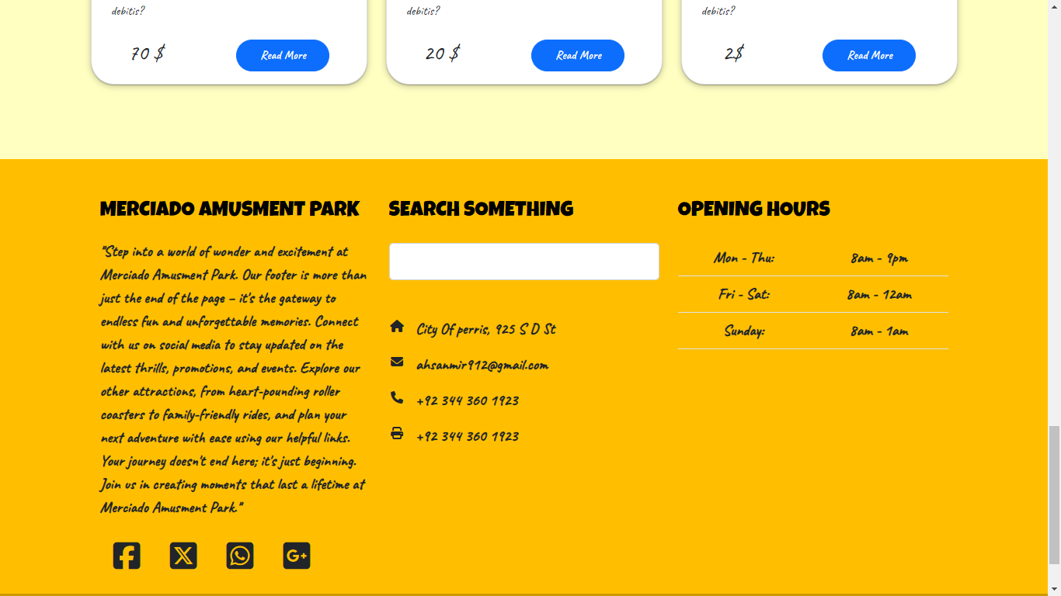



About us-page-1

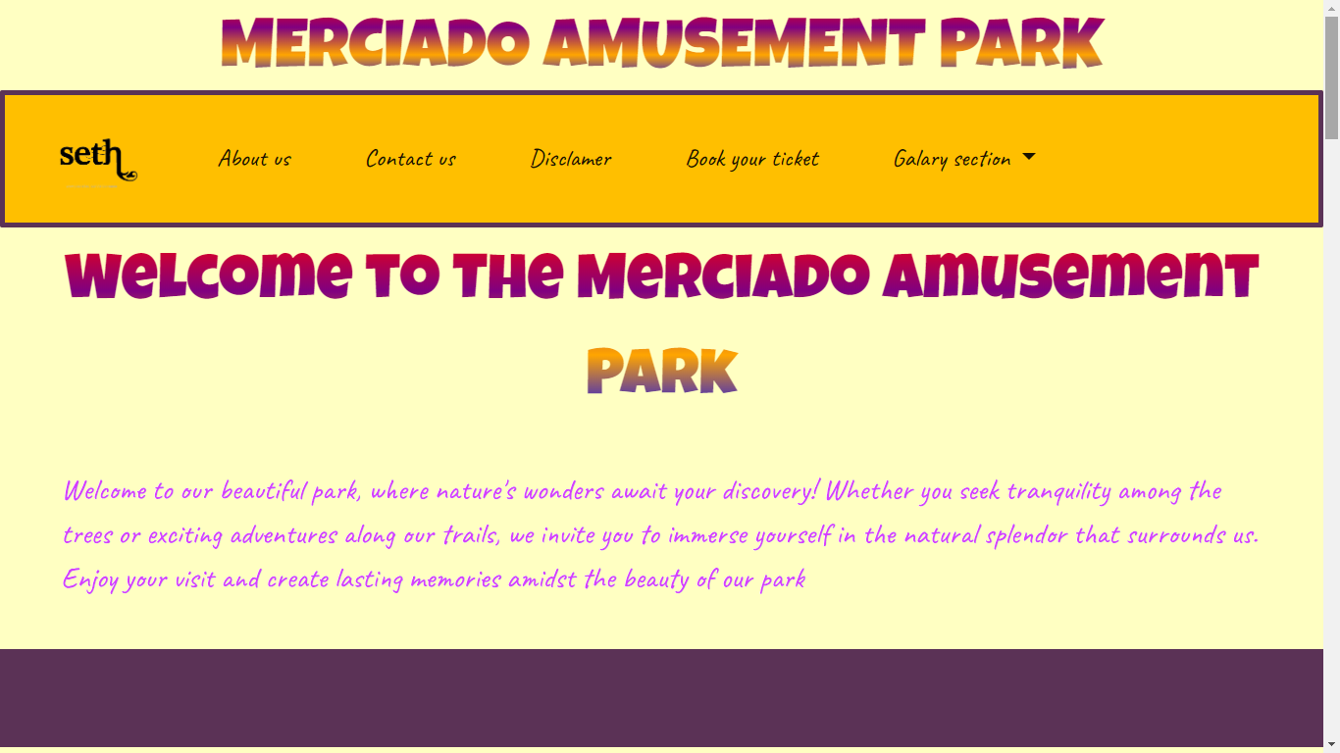

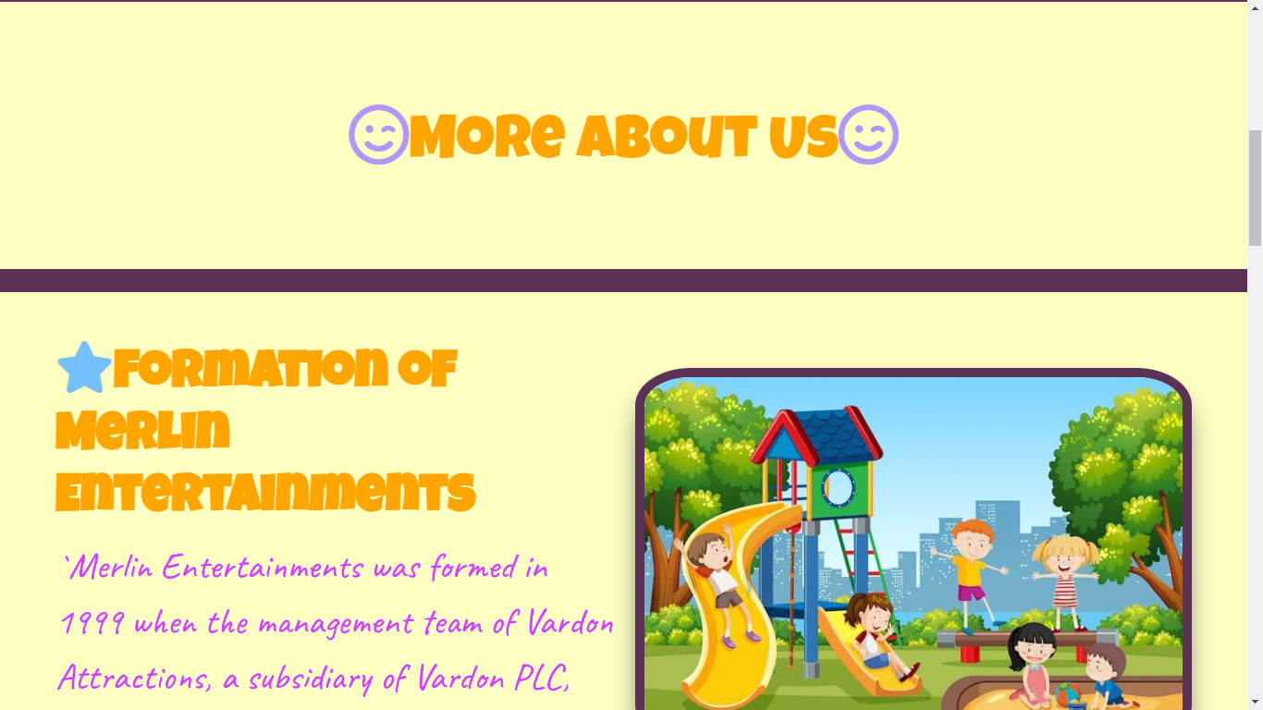



About us-page-2

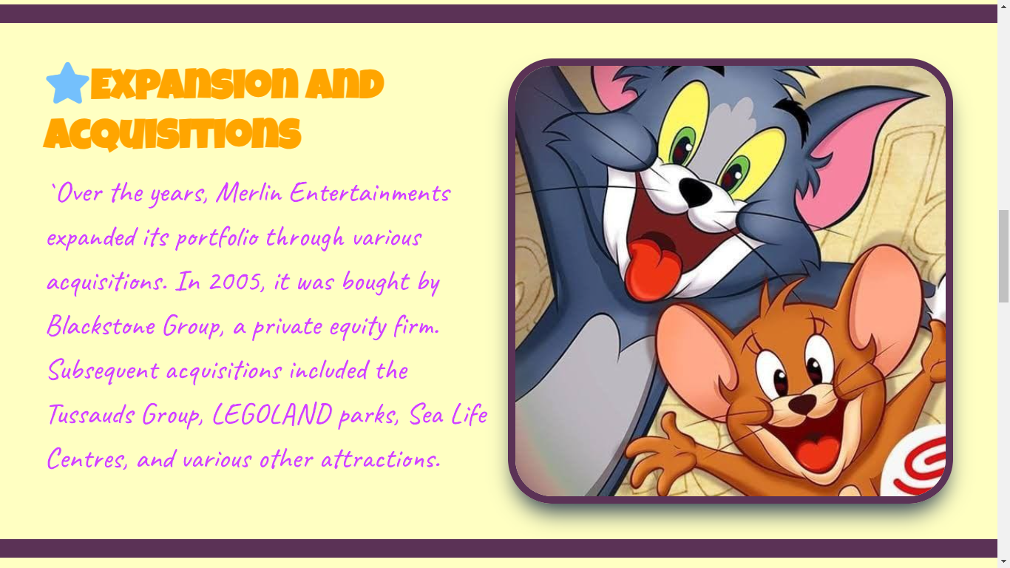

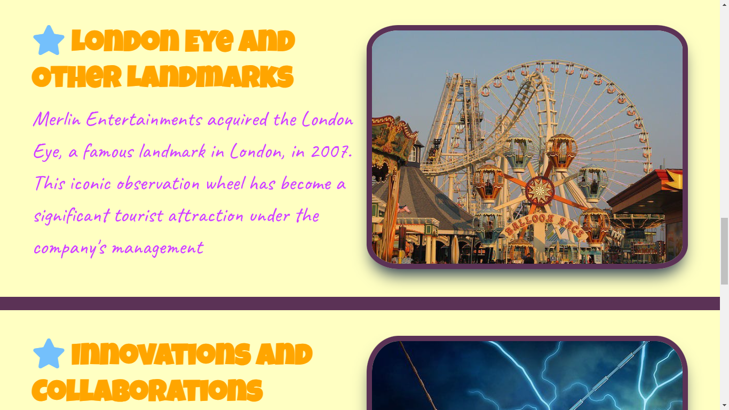



About us-page-3

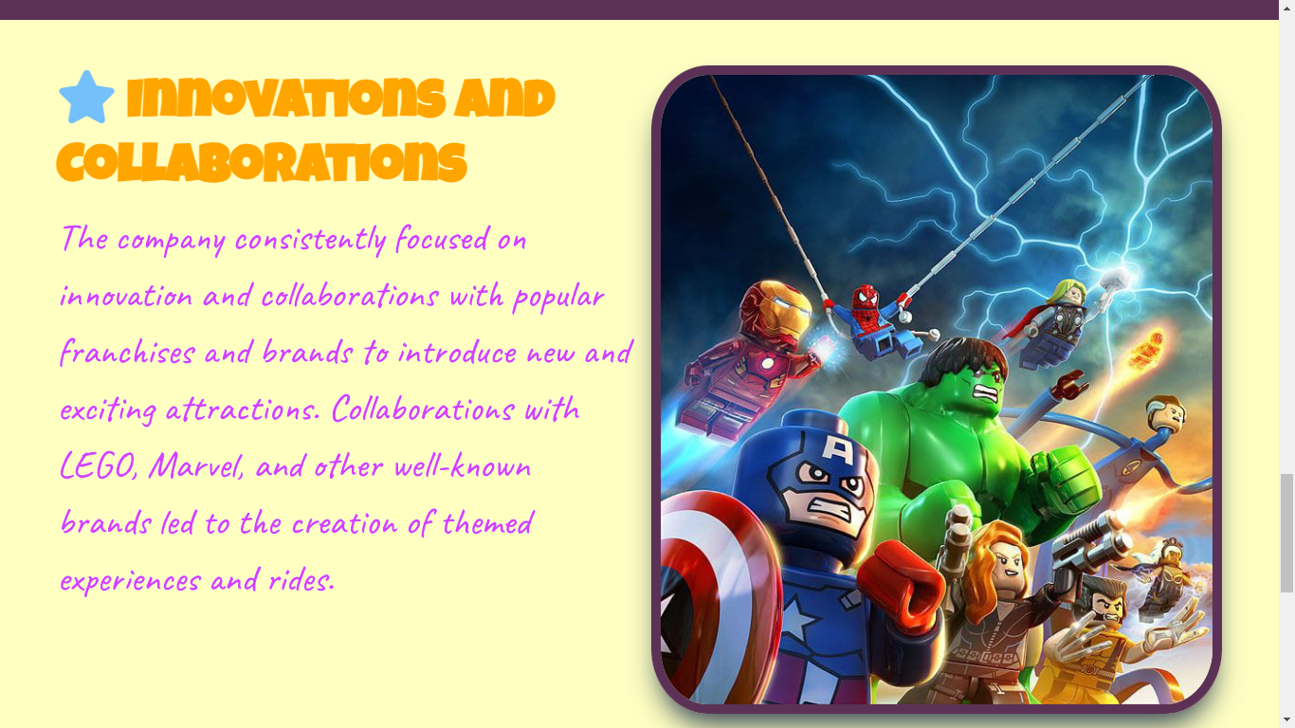



Contact-Page-1

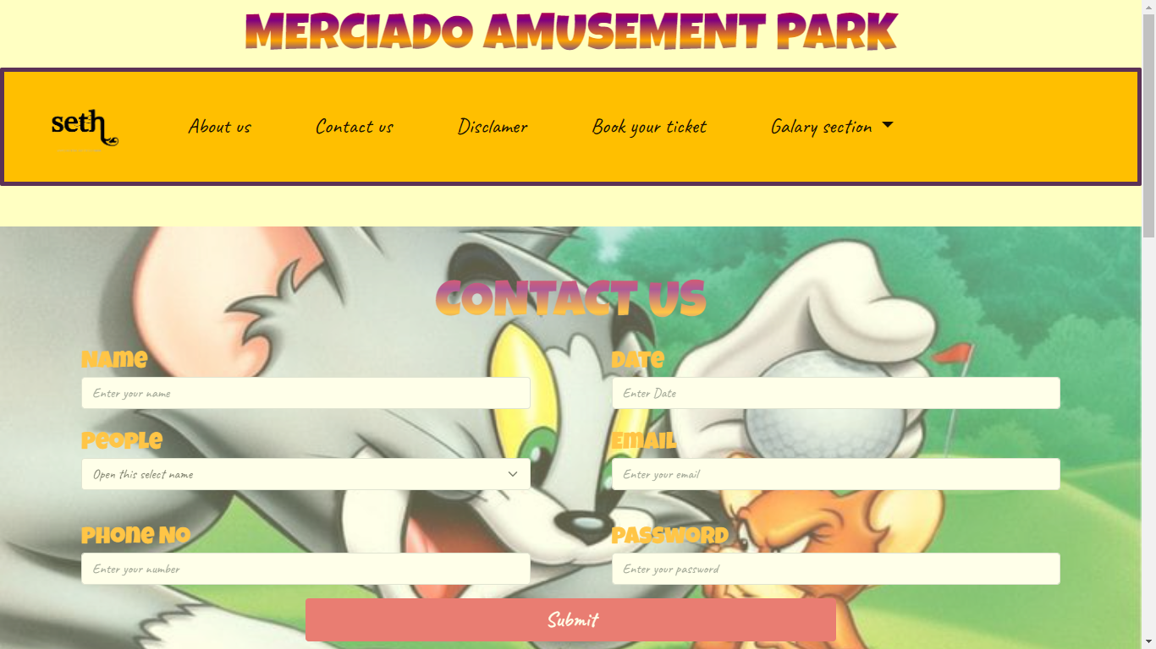

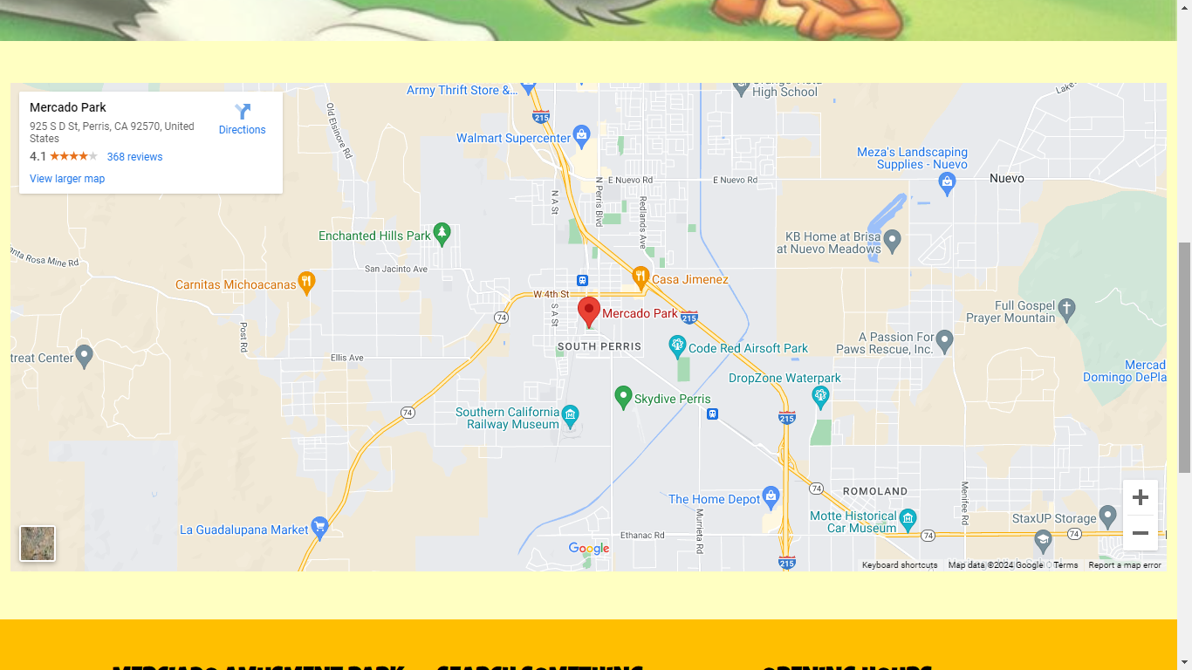



Disclaimer and book ticket -page-1

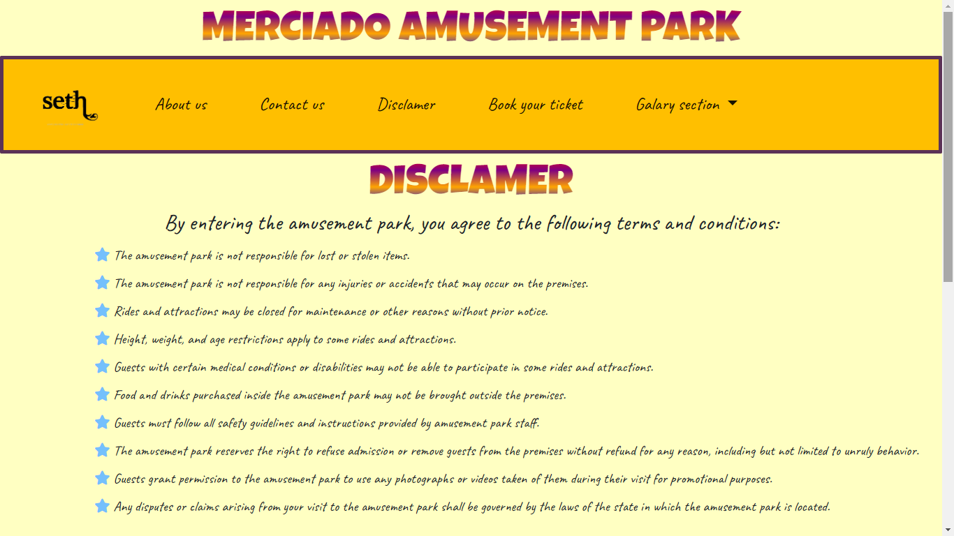

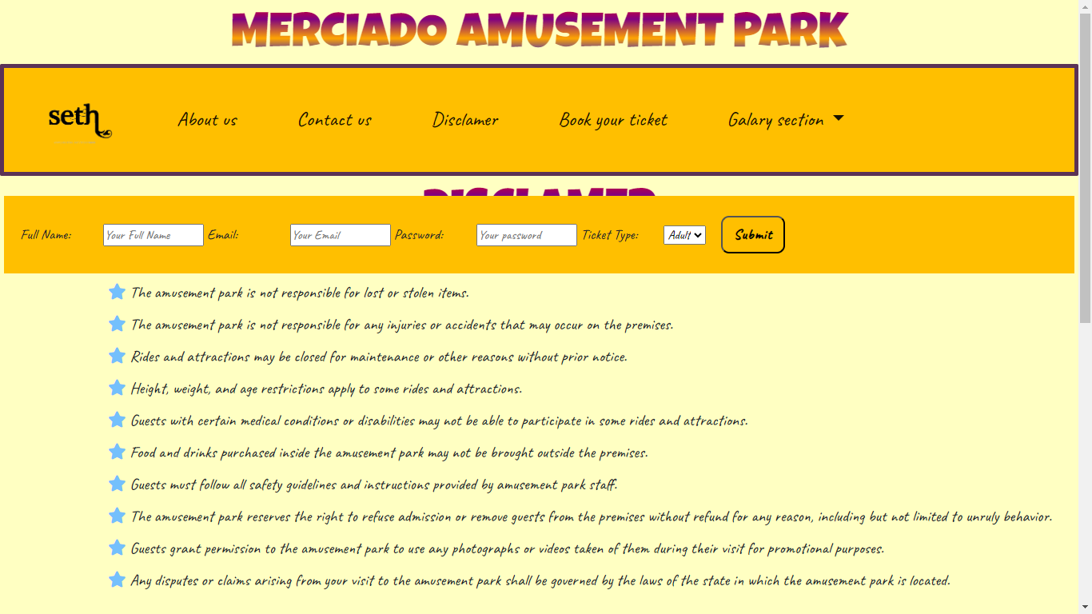



Gallary Section

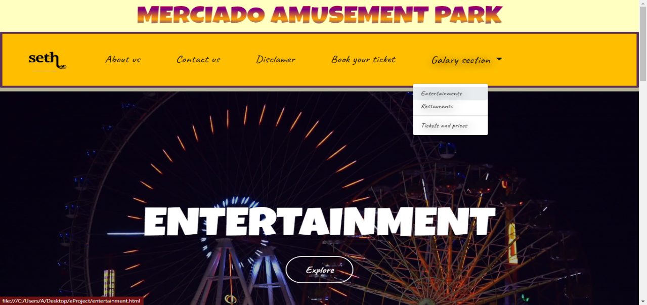

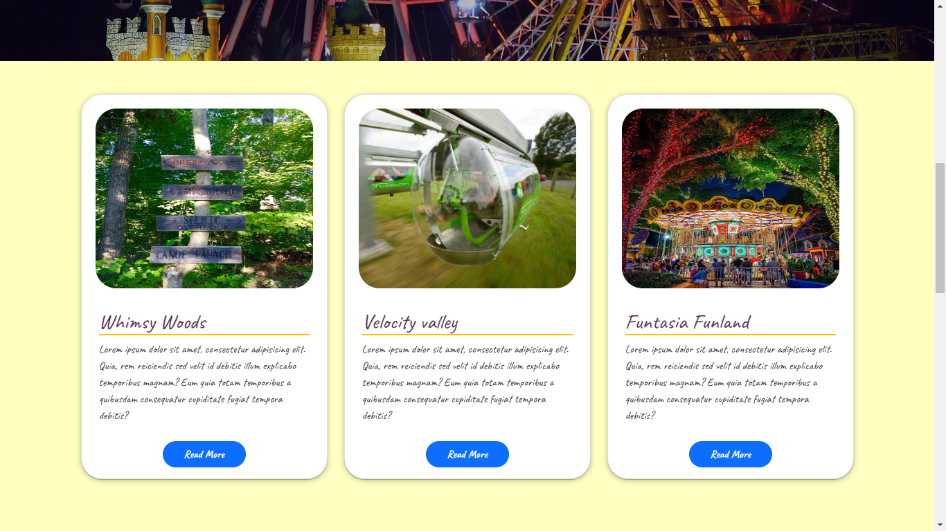



Entertainment-page

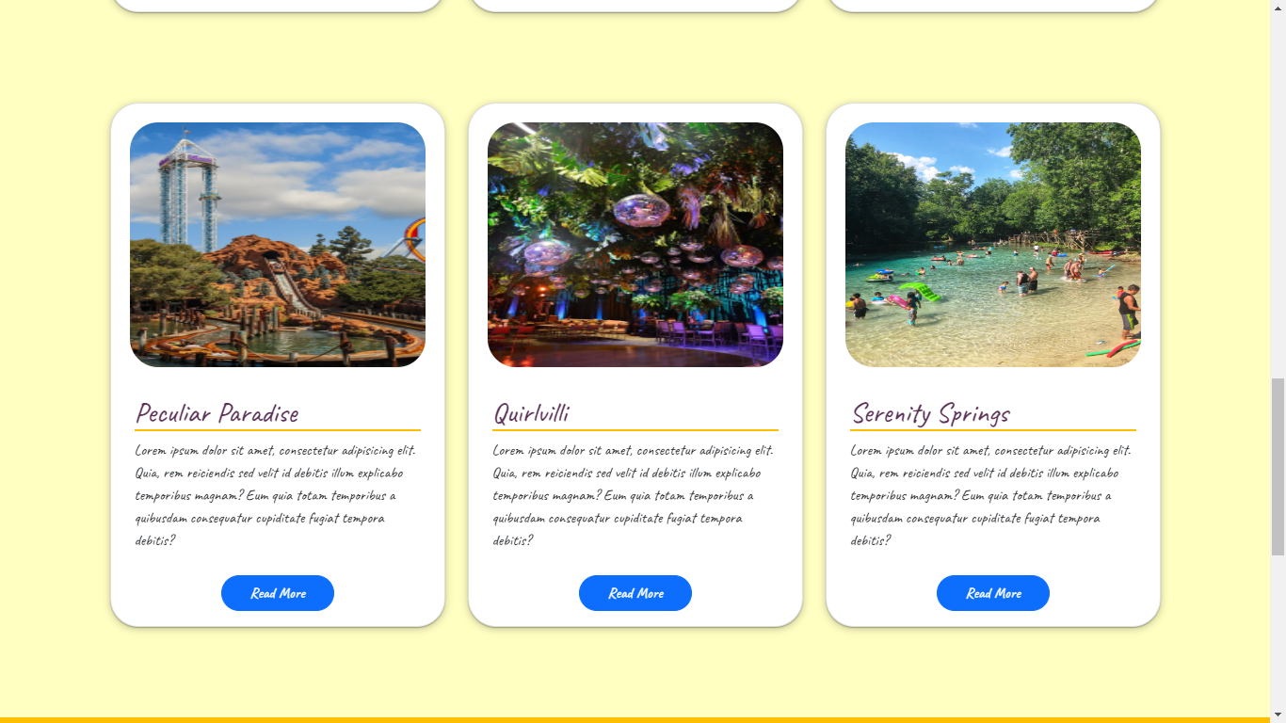



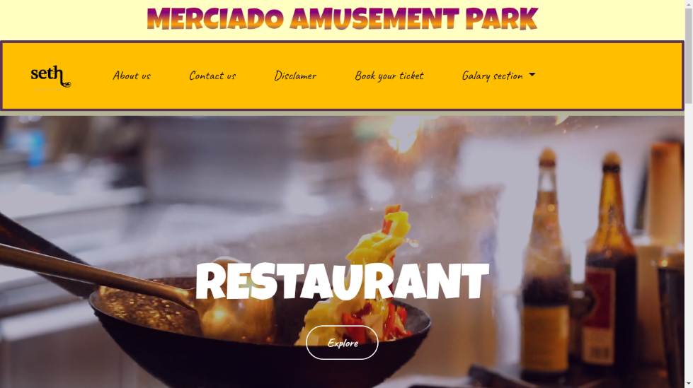RESTAURANT PAGE



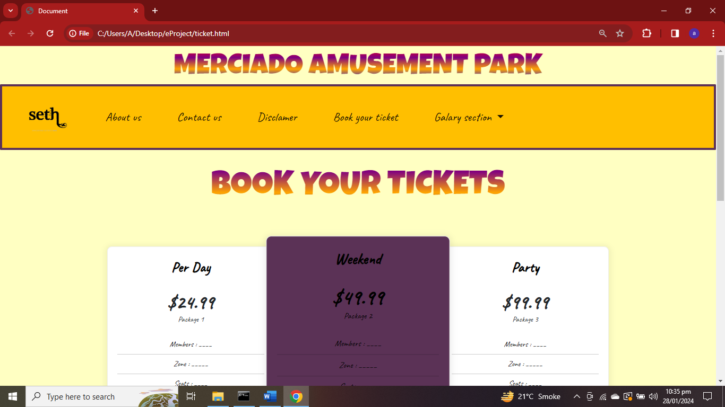

### Source of code

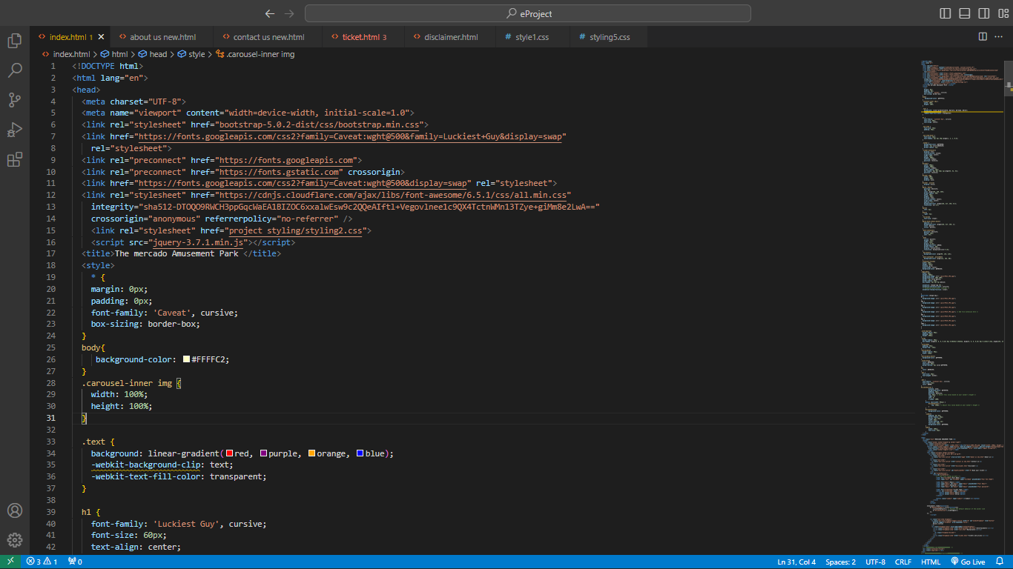Home-pg

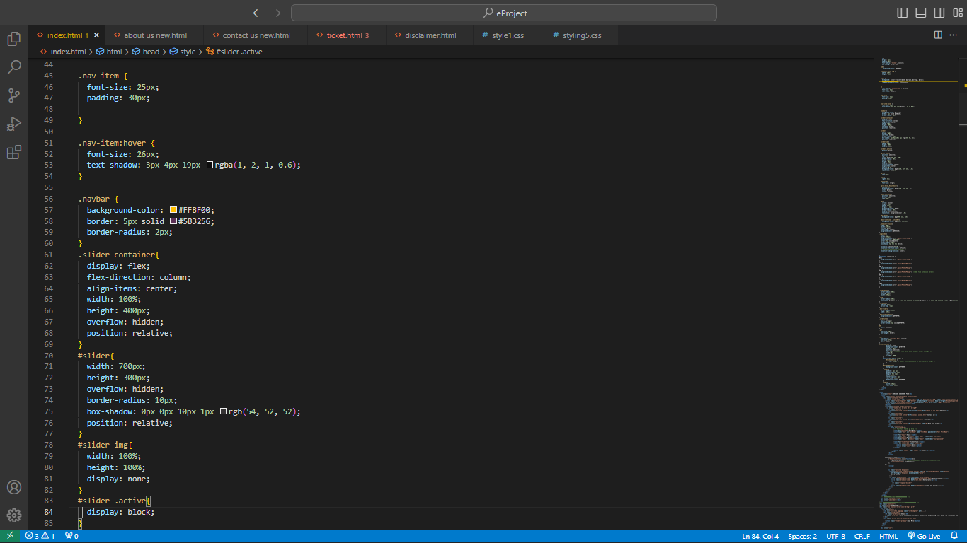

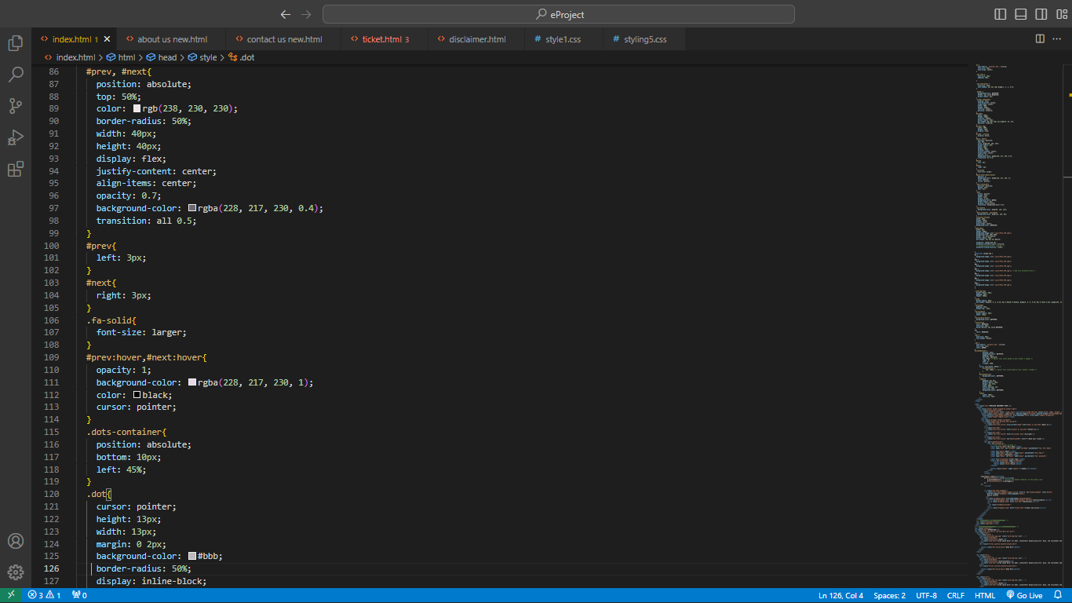



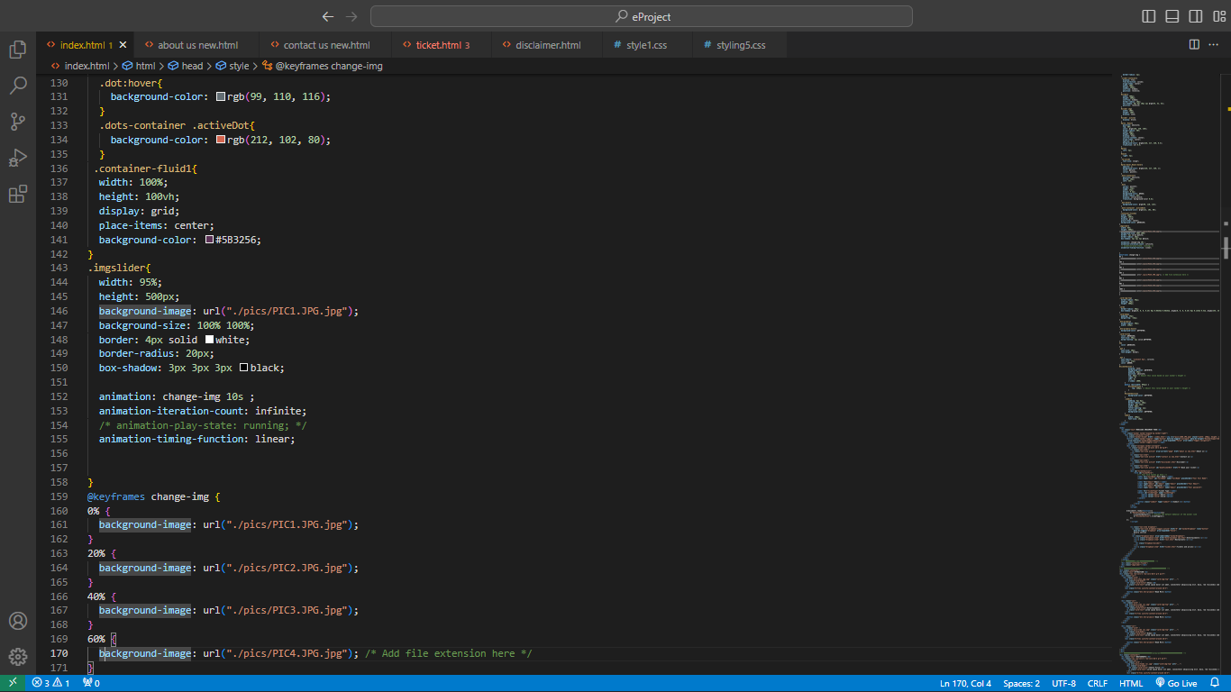

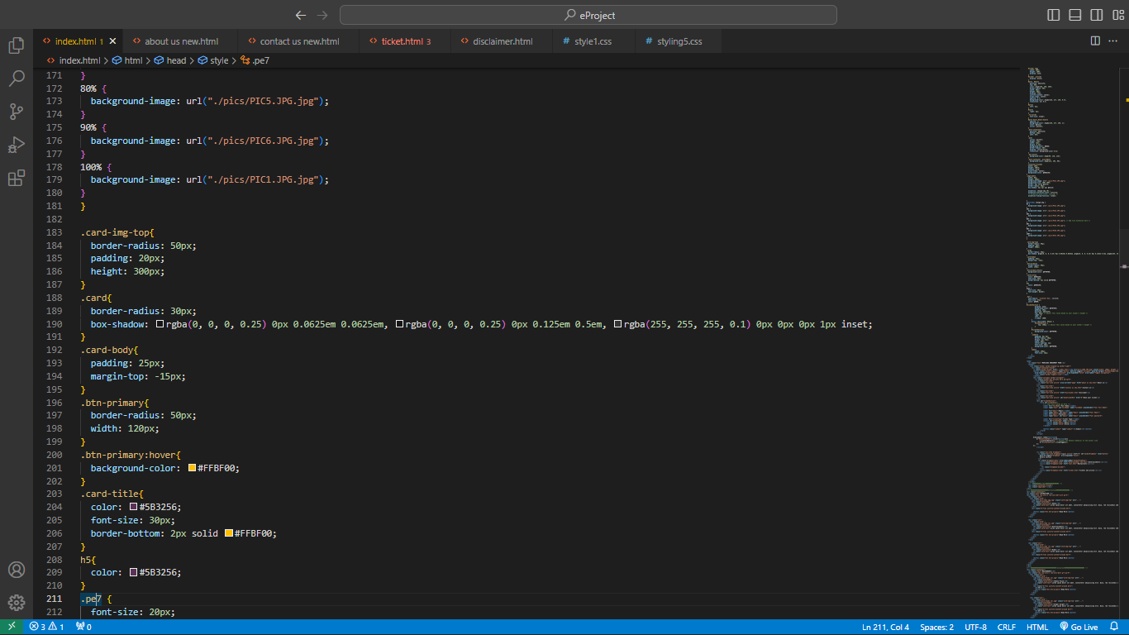

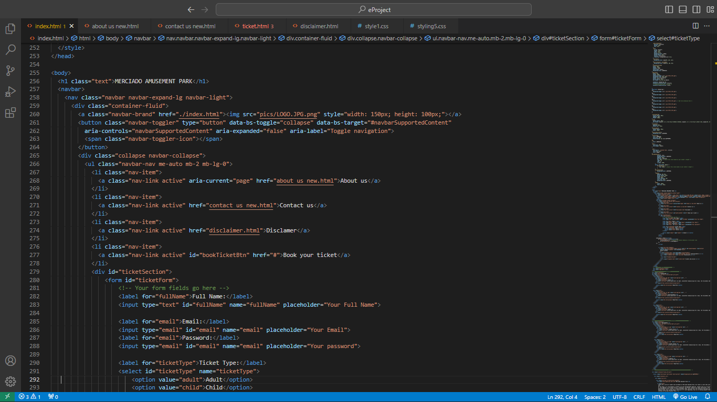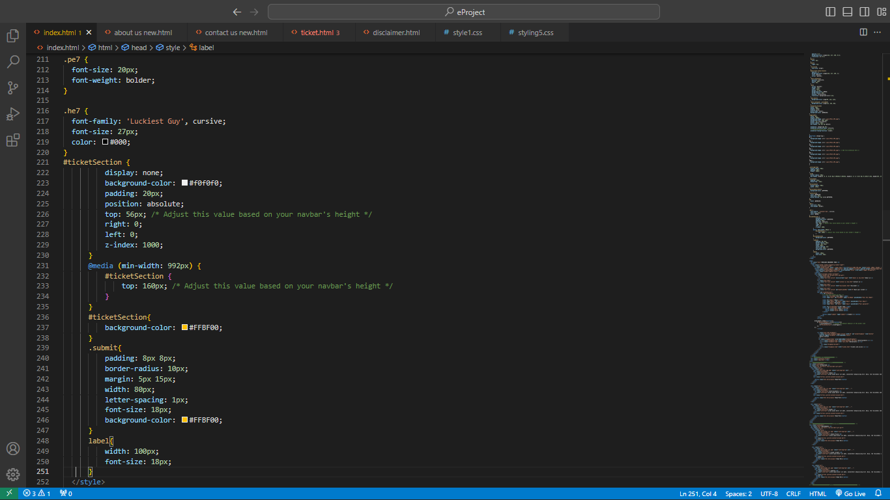

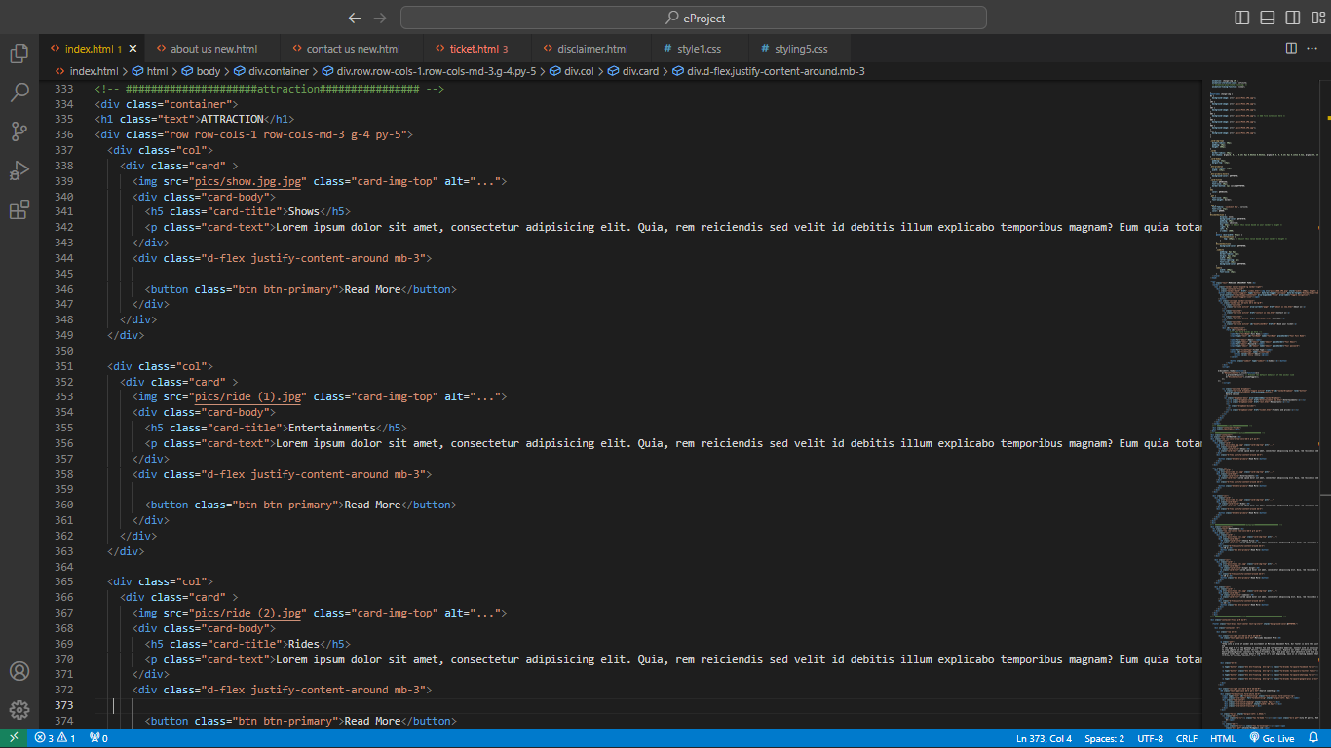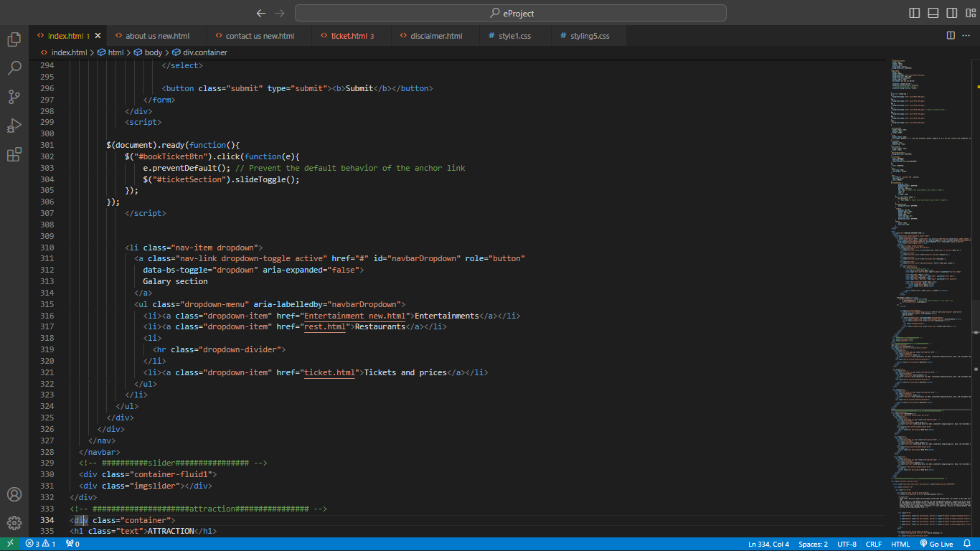



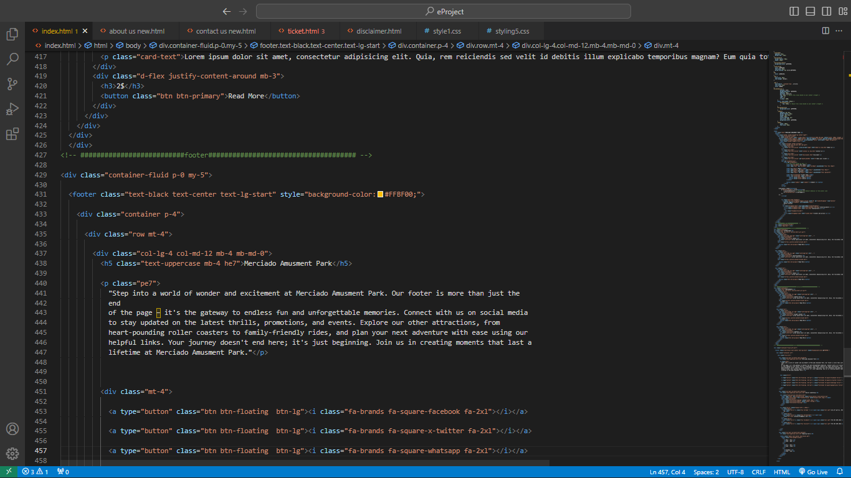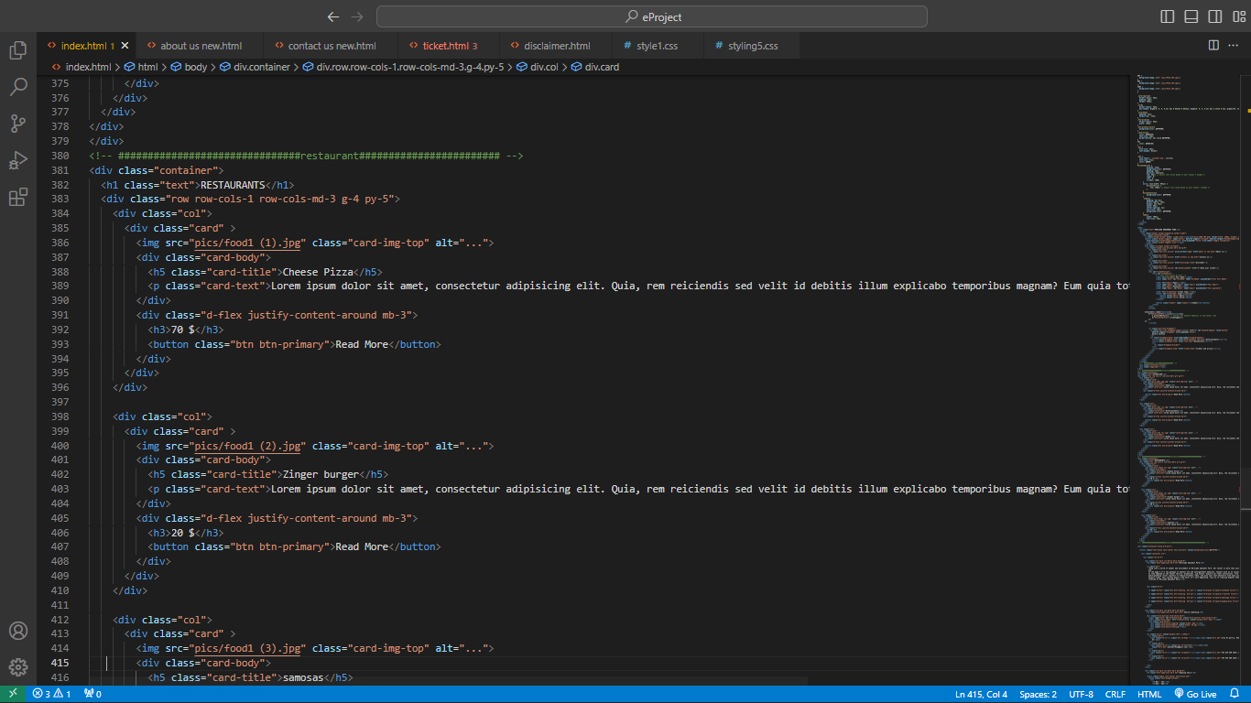

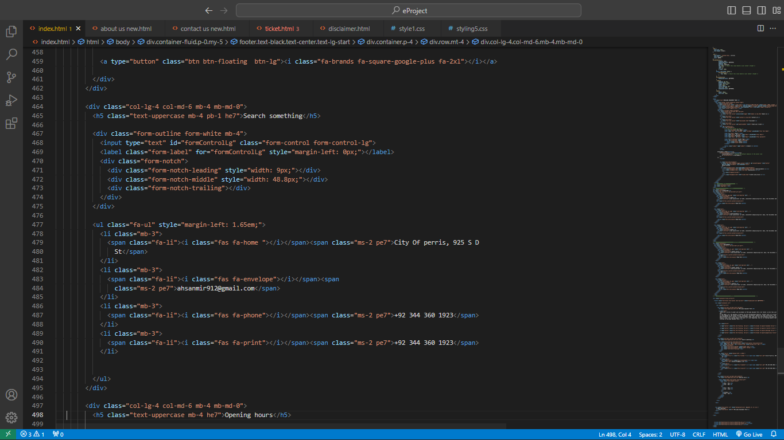



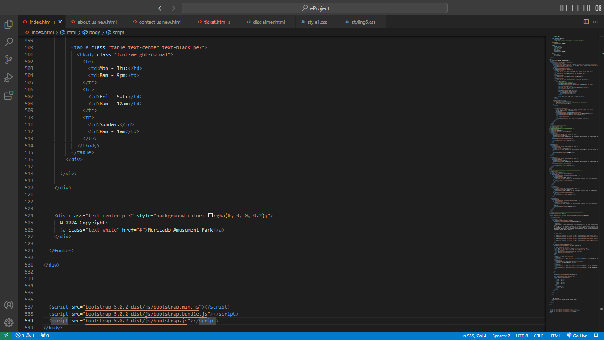

About us page

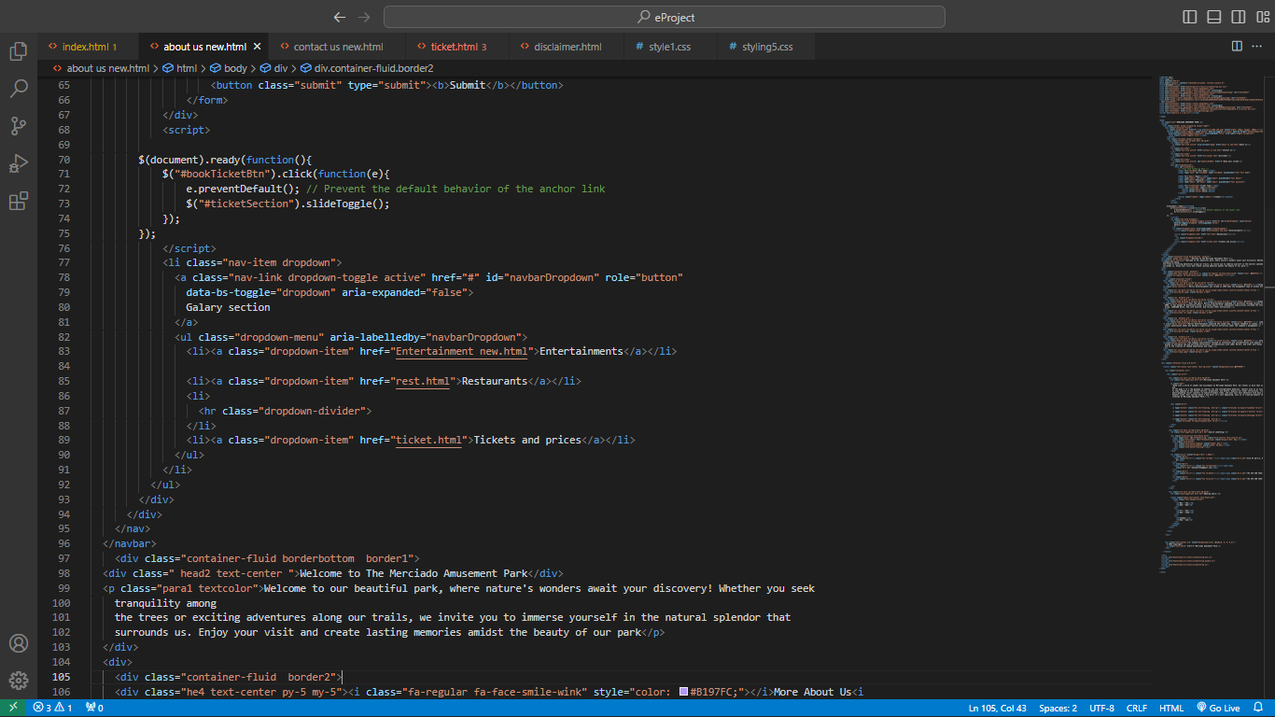

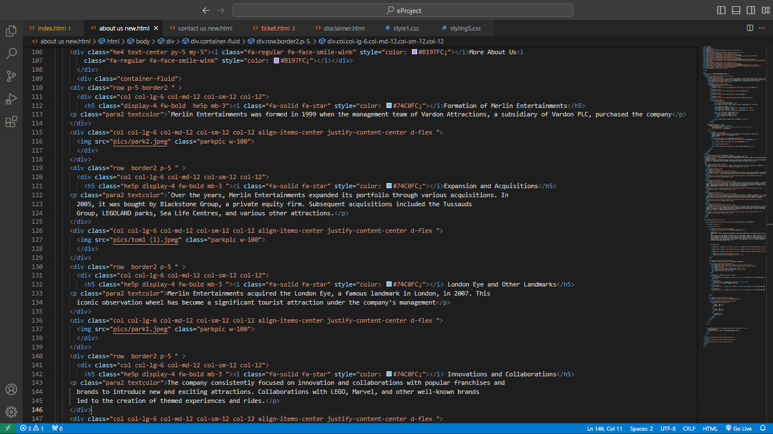

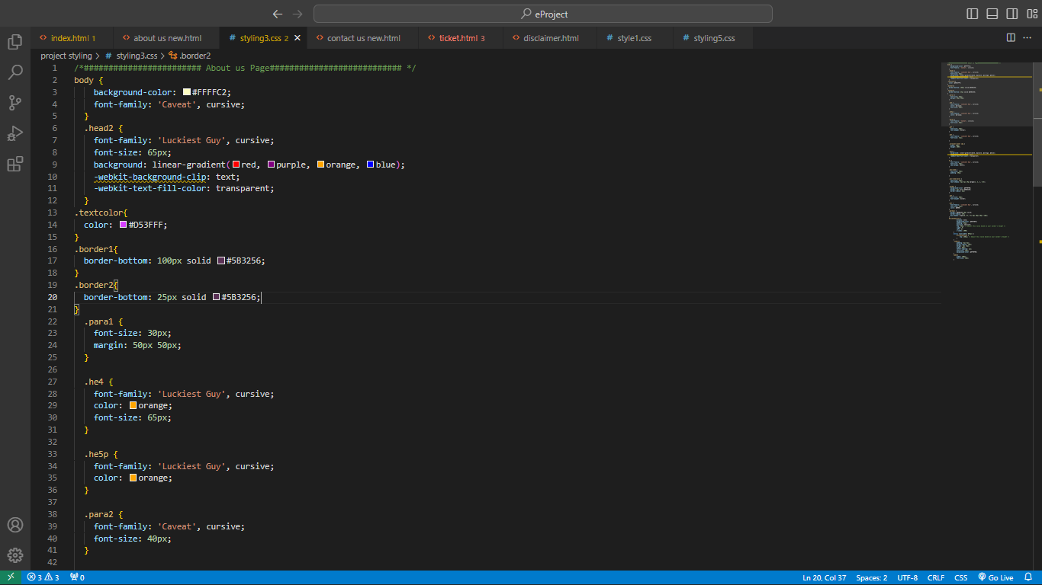

eswa

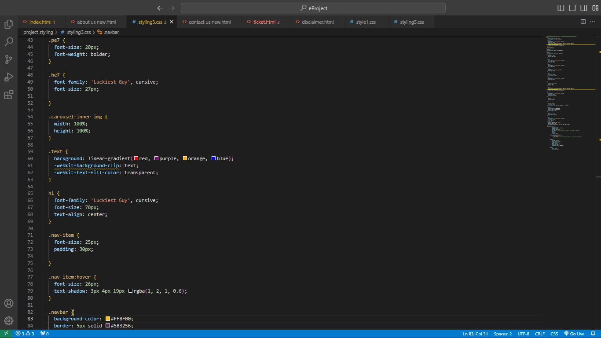

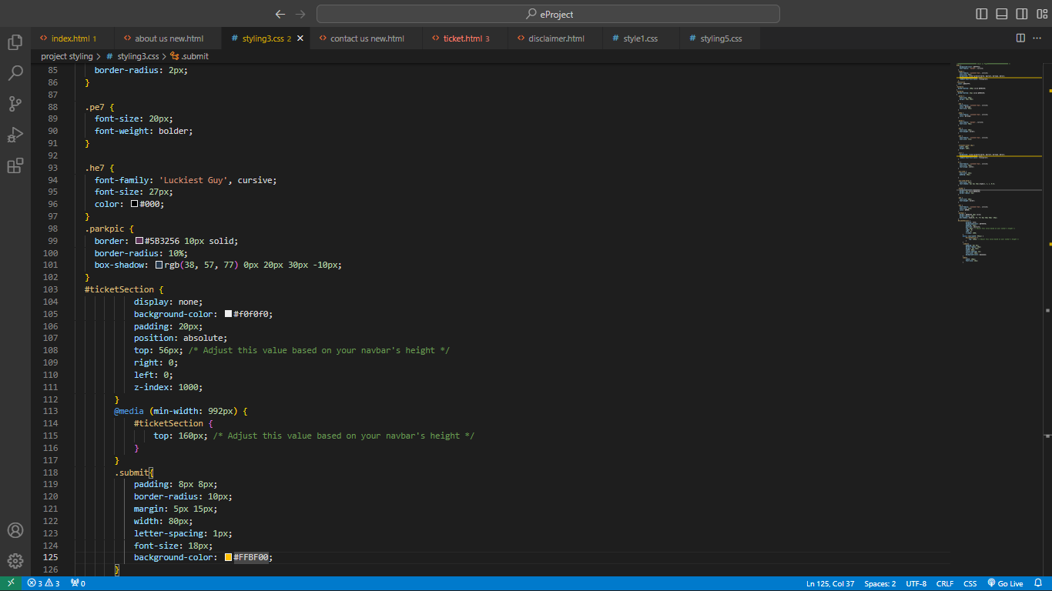

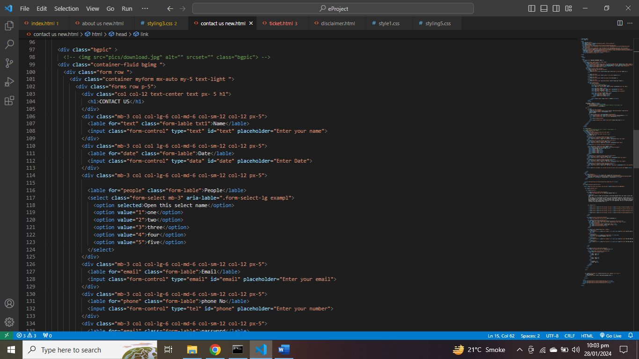



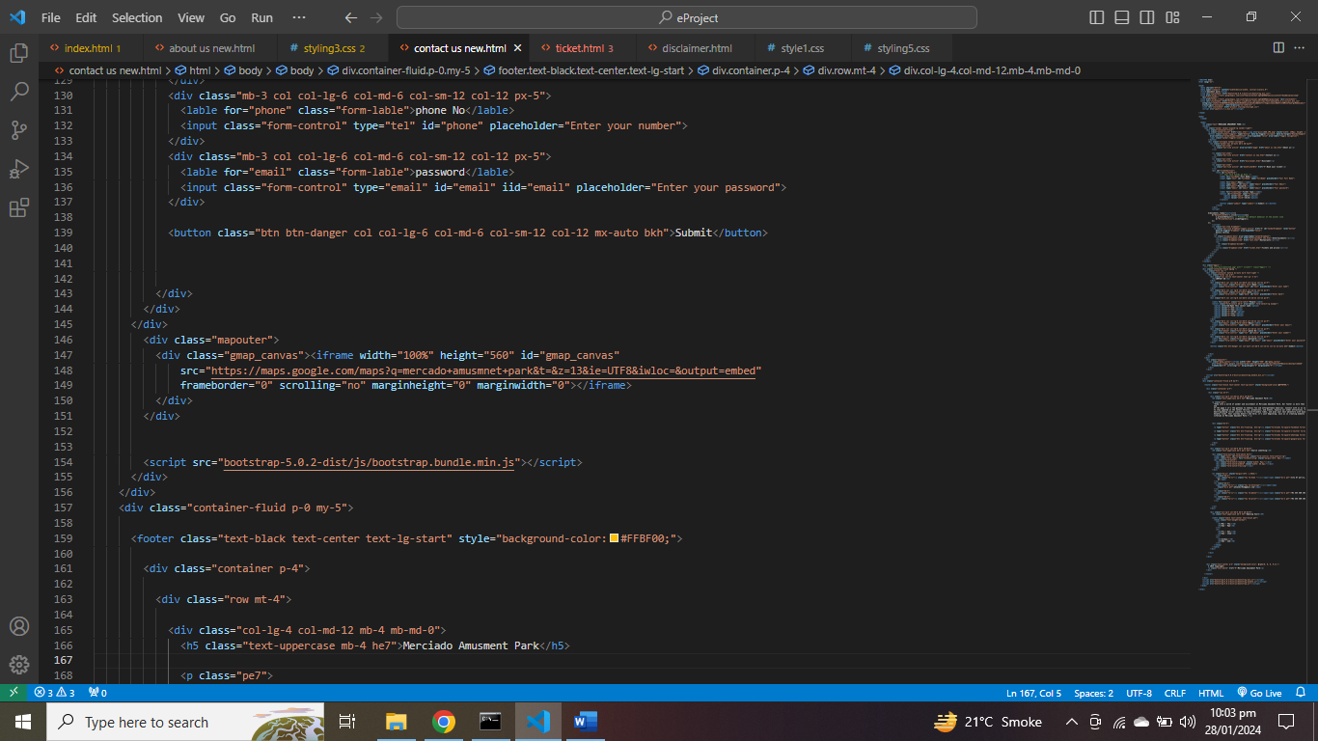

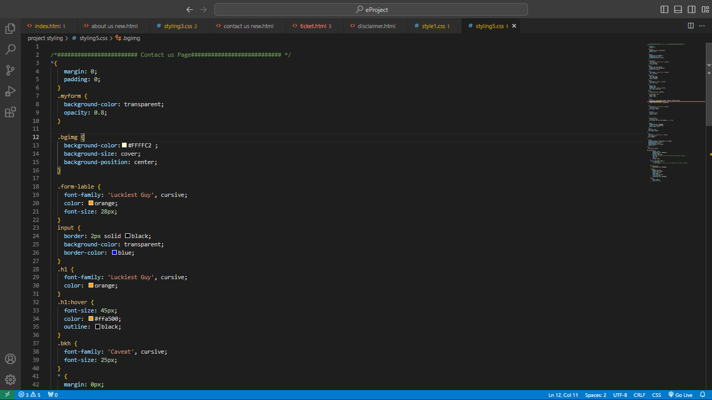

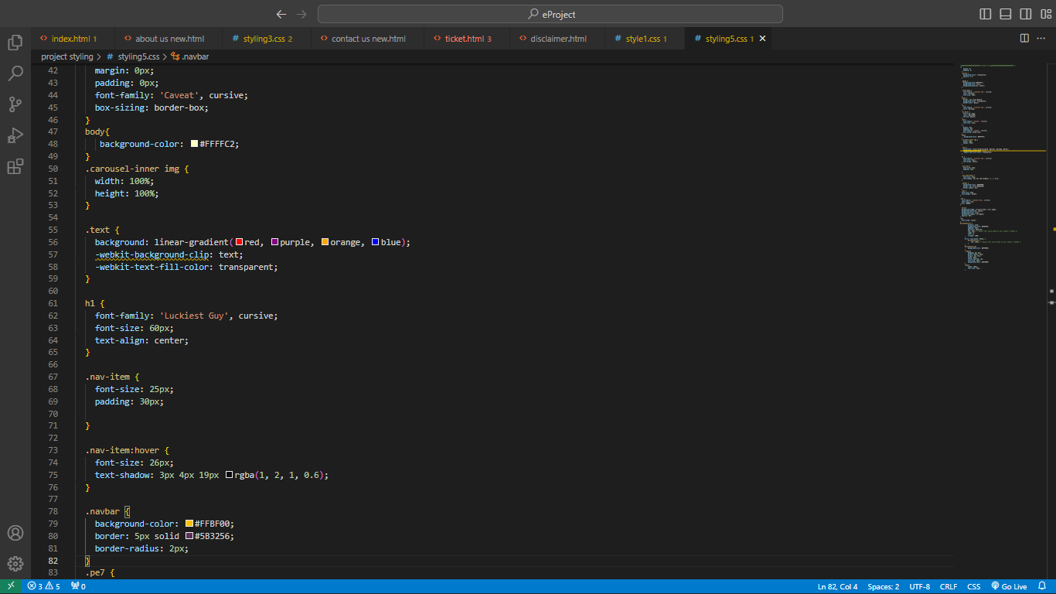



**Thank you “EPROJECT TEAM”**

# For wonderful opportunity Work for the project

THE MERCADO AMUSEMENT PARK